IWBDA 2022 Abstract Template

First Author  Second Author∗  first@corporation.com second@institute.edu | Third Author  University  City, Country third@no.name.org | Fourth Author  Research Institute  City, Country fourth@name.org

INTRODUCTION
The Fourteenth International Workshop on Bio-Design Automation (IWBDA) will bring together researchers from the synthetic biology, systems biology, and design automation communities to discuss concepts, methodologies and software tools for the computational analysis and synthesis of biological systems.
The field of synthetic biology, still in its early stages, has largely been driven by experimental expertise, and much of its success can be attributed to the skill of the researchers in specific domains of biology. There has been a concerted effort to assemble repositories of standardized components; however, creating and integrating synthetic components remains an ad hoc process. Inspired by these challenges, the field has seen a proliferation of efforts to create computer-aided design tools addressing synthetic biology’s specific design needs, many drawing on prior expertise from the electronic design automation (EDA) community.
The IWBDA offers a forum for cross-disciplinary discussion, with the aim of seeding and fostering collaboration between the biological and the design automation research communities. Topics of interest include:

- Design methodologies and tools for synthetic biology.
- Standardization and characterization of biological components.
- Automated assembly techniques.
- Computer-aided modeling, simulation, analysis, and abstraction techniques.
- Engineering methods inspired by biology.
- Domain specific languages for synthetic biology.
- Data exchange standards and models for synthetic
biology.
This document is a MS Word template for an IWBDA abstract.

CONTENTS OF THE ABSTRACT
The abstracts must use this MS Word template or the LaTeX ACM template (SIGCHI version). Abstracts should be submitted in pdf format and should not exceed two pages excluding figures and tables.

Figures
Figures are highly encouraged in your abstract. It always helps having a visual representation of your methods or results. Figure 1 shows an example of a smaller figure that spans just 1 column.
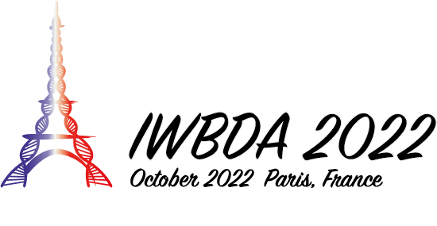
Figure 1: A figure spanning just one column
Figure 2 shows how large figures that span both columns can be displayed. Figure captions must appear beneath a figure.

Tables
A table’s heading must appear above the table. Table 1 shows an example of a table. Like figures, large tables may span multiple columns.
Table 1: Table Heading
Column 1 | Column 2
a | 1.0
b | 2.0

Bibliography
Figure 2: You can show a figure that spans both columns.
For the bibliography, please make sure you use the ACM style as in the References section of this template. This is an example of a citation [1].

SUBMISSION
Abstracts must be submitted via EasyChair using this link. If you do not have an easy chair account, please create one by following the instructions specified here. Please make sure that you include the full names, affiliations and contact information of all authors. Please make sure you indicate whether you would like your abstract considered for a poster presentation, an oral presentation, or both. Abstracts will be reviewed by the Program Committee. Those that are selected for oral and poster presentations will distributed to workshop participants and posted on the workshop website.

While submitting your abstract for review, please make sure that you include line numbers in the document to assist with the review process. To add line numbers in your Word document, go to Layout, and select “Continuous” under the “Line Numbers” option. This will add the numbers to the side of the document which makes it easier to review your abstract. If your abstract is accepted, please make sure you remove the line numbers.

The deadline for Abstract Submission is: 22^{𝑛𝑑} July 2022 (anywhere on Earth).

Contact
If you have any questions regarding this template or submissions, please send an email to Ayush Pandey. You can find more information about IWBDA on the website. You can also contact the committee by sending an email.

REFERENCES
[1] Lamport, L. LATEX: a document preparation system: user’s guide and reference manual. Addison-wesley, 1994.

